I started this desk right after Christmas….but really it started in spring of 2009 when our two big twin oaks came down and I cut the logs and had them taken to the sawmill to be milled into rough sawn lumber and then kiln dried. Much of my ‘work’ comes from turning the rough sawn lumber into finished, trued, dimensioned lumber.

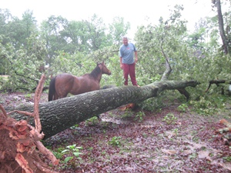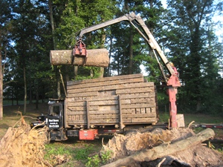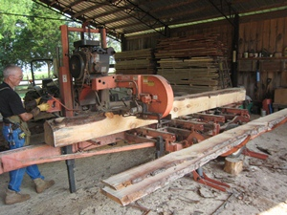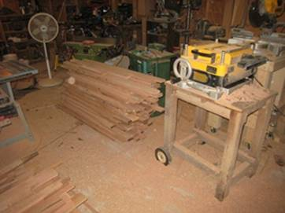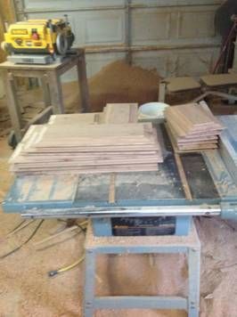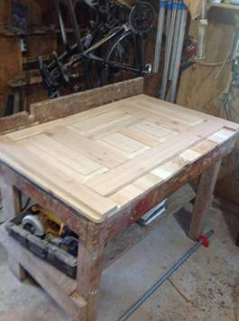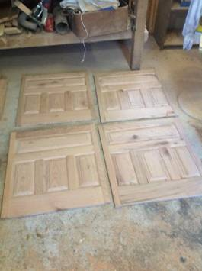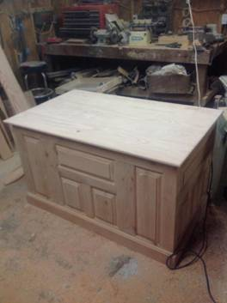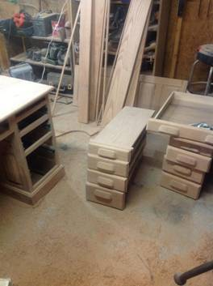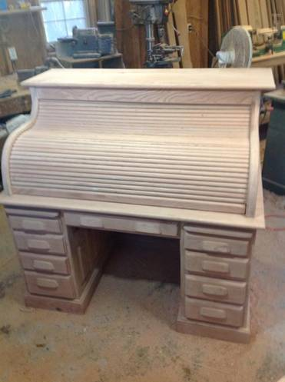 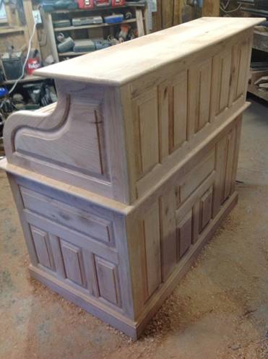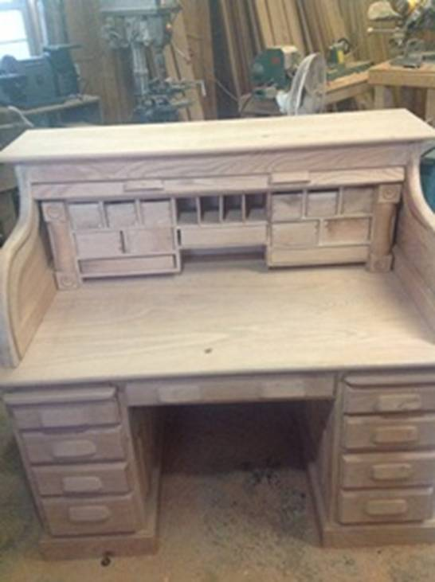

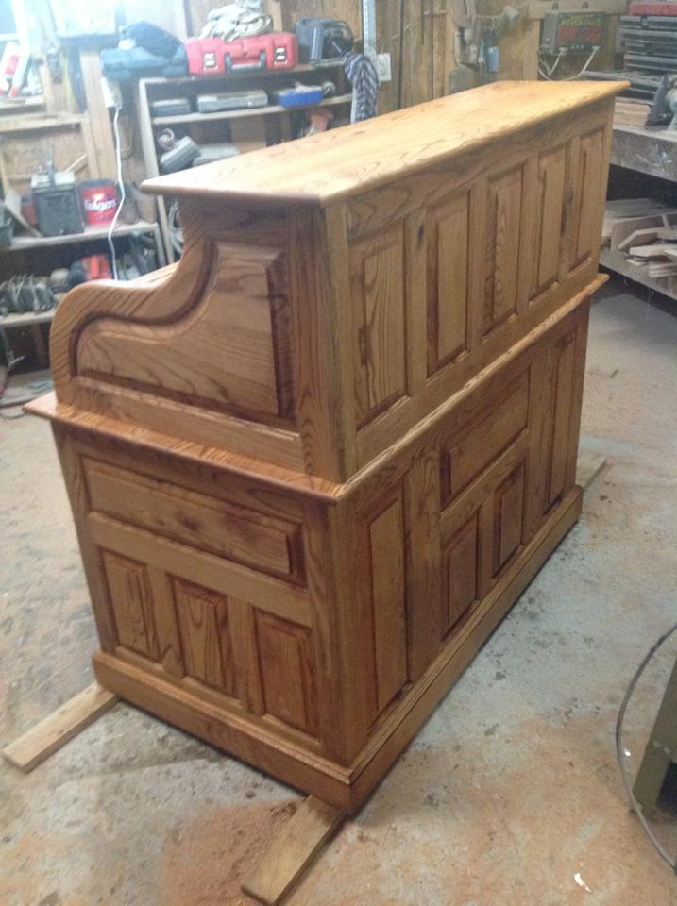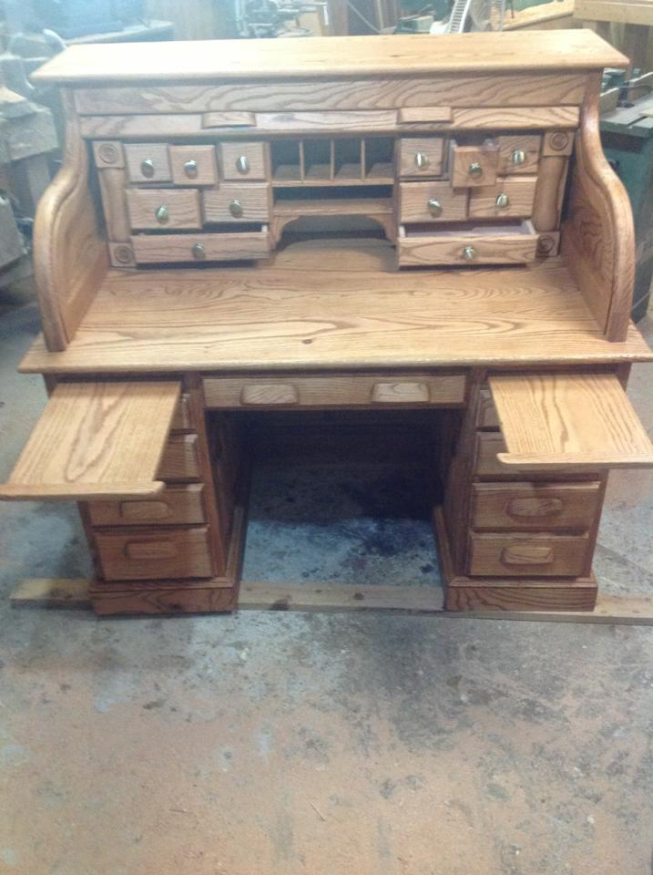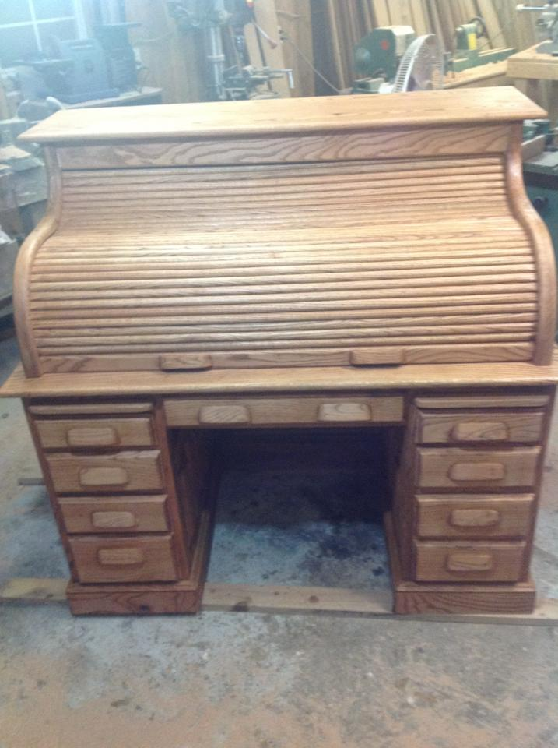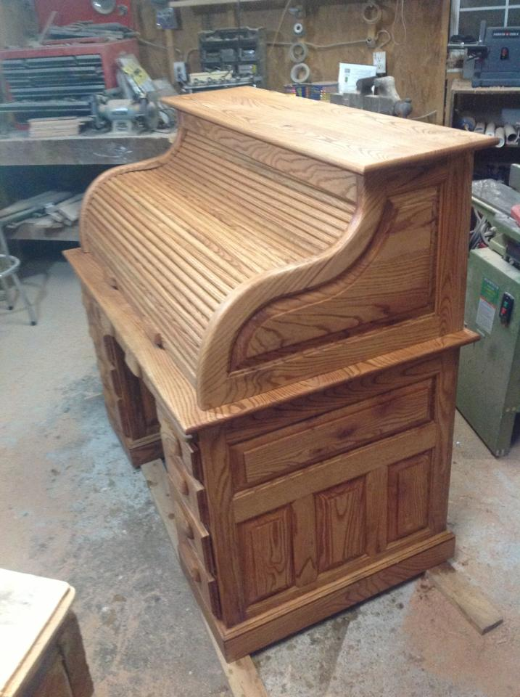

I put a couple of secret hiding places in the hollow spot behind the columns (see picture below). I turned a column and then split the column and mounted it to a board that I had tuned to precisely fit the hollow. No nails or glue or hinges to keep the columns in place, just a really tight fit. If you pull on the columns they will come off revealing a drawer in the hollow spot. Inside the hollow is a vertical drawer that pivots or rotates out.

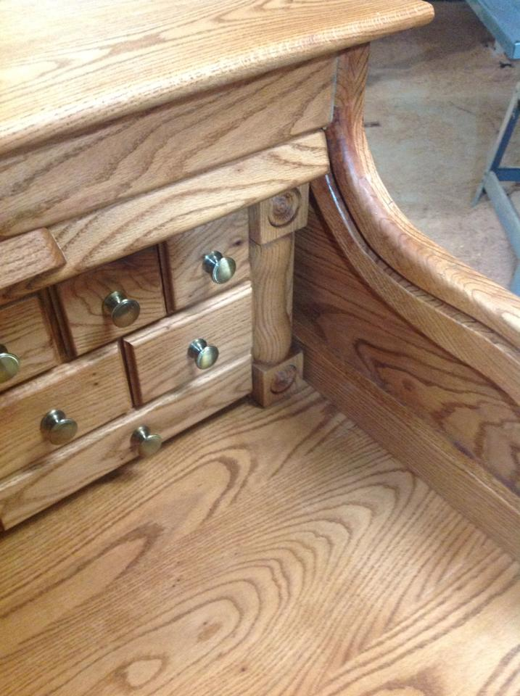 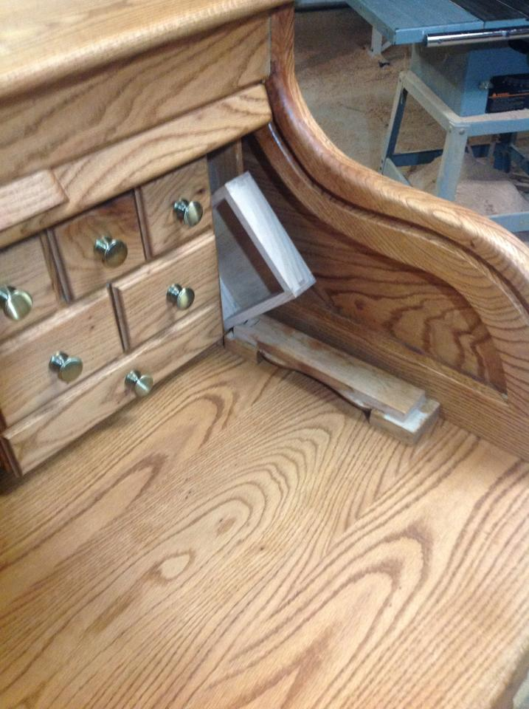

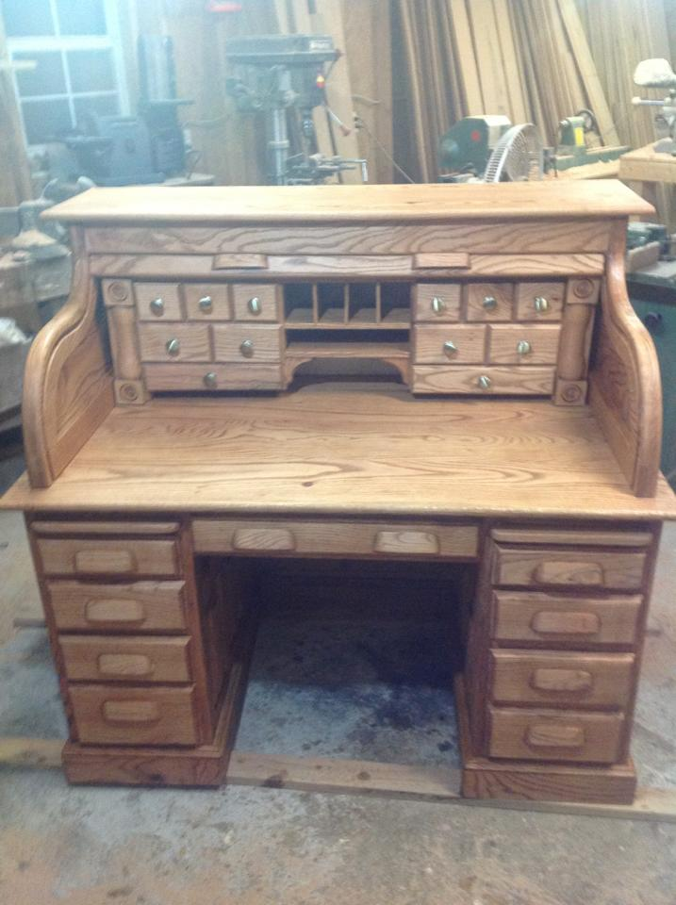

The (almost) finished desk – a couple of coats of polyurethane and then I’ll move her into the house.

This was my most ambitious project to date. I estimated there are approximately 350 separate pieces of wood in this project. I paid 35 cents a board foot to have the oak trees milled into lumber and 20 cents a board foot to have it kiln dried. When you mill your own trees though, you get warts and all. So I went through a lot of lumber culling out the knots, splits and rotten/spalted wood to get grade 1 lumber. But even with all the scrap, my lumber cost was negligible. So far those twin oak trees have been used for oak flowing for our dining room and foyer, build this desk and I still have about ½ of the lumber left. I used sycamore for the internal drawers planed down to 1/2” to reduce the weight of the desk.

Ever since I got my iPad, I haven’t taken any pictures with our digital camera since the iPad takes such good pictures. But I got out of the habit of uploading pictures to this on-line site where most of my projects are shown.

<http://s184.beta.photobucket.com/user/CasMicRog/library/Mikes%20Woodwork/?fromLegacy=true#/user/CasMicRog/library/Mikes%20Woodwork?http%3A//s184.beta.photobucket.com/user/CasMicRog/library/Mikes%20Woodwork/?&_suid=1361201178649033198673912555776>

I would like to thank Mrs Rogillio for her support of new tool purchases and for allowing me to disappear for hours on end in my man cave to make sawdust. I’d especially like to thank Pieter van Vliet who laid out the project on his website (Dempsey Woodworking) where my iPad camped out for 2 months following his plans for this desk.